BEEE LAB EVALUATION

NAME : DEV PRATAP SINGH

UID:19BCS4622

CLASS : CSE IOT(2)

AIM: **29. Design a DJ system that produces a. Red light when a button is pressed during day. b. Green Light when a button is pressed during night.**

APPRATUS :

1. BREADBOAD
2. ARDUINO
3. WIRES
4. LED
5. LDR
6. RESISTOR

CIRCUIT DIAGRAM:

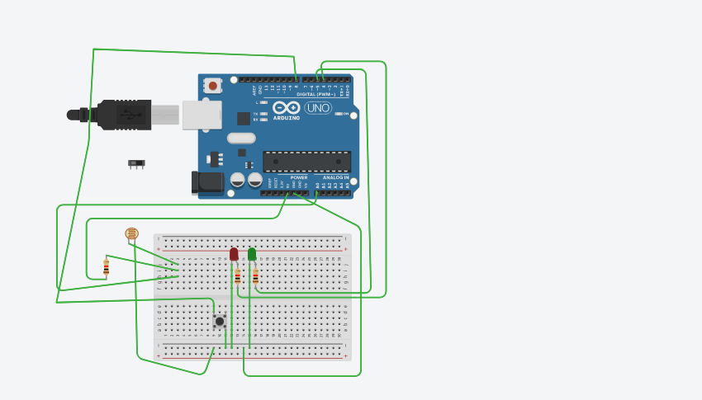

SOURCE CODE:

void setup()

{

Serial.begin(9600);

pinMode(4, OUTPUT);//red

pinMode(5, OUTPUT);//green

}

void loop()

{

int d=analogRead(A0);

Serial.println(d);

if(d>600)

{

digitalWrite(5, HIGH);

delay(1000); // Wait for 1000 millisecond(s)

digitalWrite(5, LOW);

}

else

{

digitalWrite(4, HIGH);

delay(1000); // Wait for 1000 millisecond(s)

digitalWrite(4, LOW);

}

}